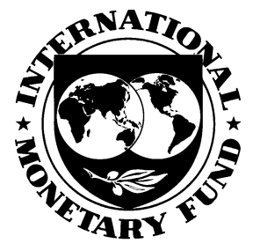
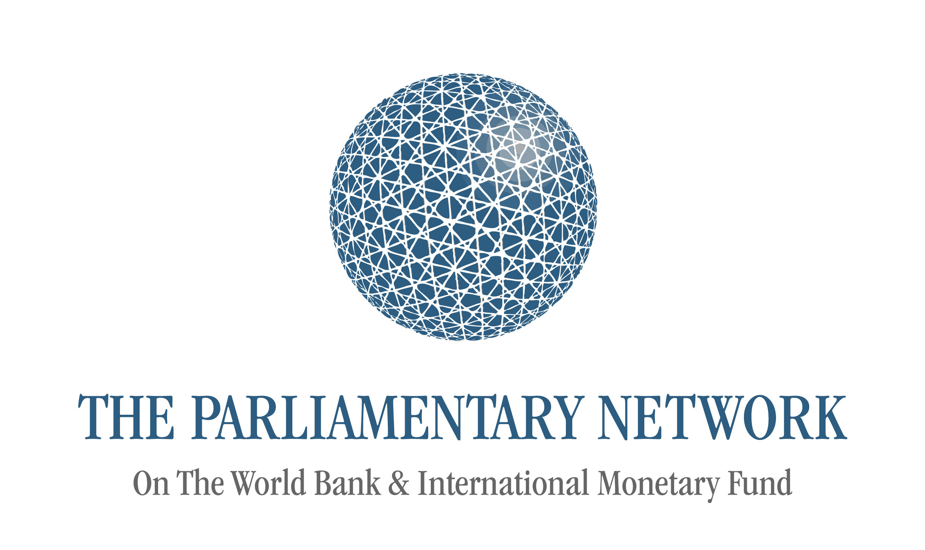


World Bank/IMF Spring Meetings
The Parliamentary Network delegation draft program
17-18 April 2013

Venues
Hotel 1: Courtyard Marriott/Foggy Bottom  515 20th Street NW, Washington, District Of Columbia 20052  Phone: 1-202-296-5700 | Hotel 2: Embassy Row Hotel  2015 Massachusetts Avenue NW, Washington, District of Columbia, 20036  Phone: 1-202-265-1600
World Bank Group  1818 H Street, NW | International Monetary Fund  700 19th Street, NW

Emergency contacts

PNoWB duty cell phone +33 6 42 52 92 45
Police/Fire/Medical 911
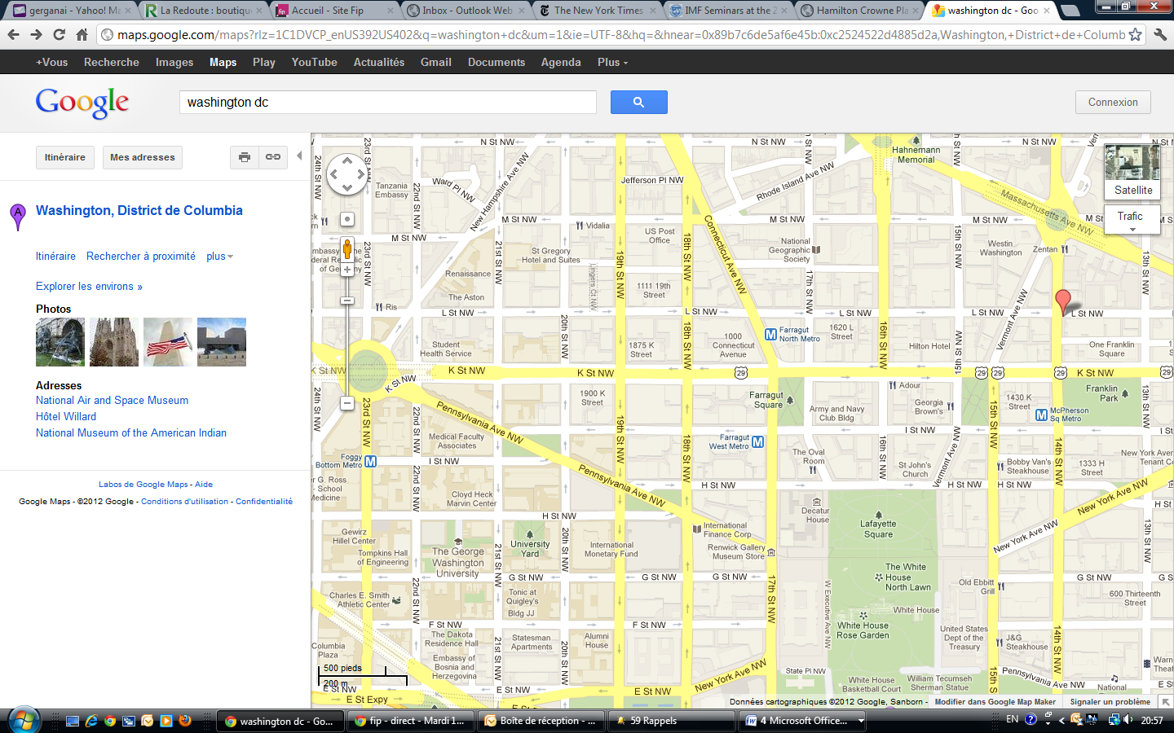

Badge
Pick-up

World Bank
IMF

Draft program

Tuesday, 16 April 2013
Upon arrival | Check-in at Hotel | Venue: Courtyard Marriott, DC/Foggy Bottom OR Embassy Row Hotel
8.30 am – 5.30 pm | WB/IMF Spring Meetings  -Registration and badge pick-up  (Only for those needing SM badges, others will have day-passes) | Venue: I building,  World Bank,  1850 I Street N.W.
Free evening

Wednesday, 17 April 2013
7.30 am – 8.00 am | Breakfast at Hotel | Venue: Courtyard Marriott, DC/Foggy Bottom OR Embassy Row Hotel
8.15 am | Transfer from Hotel Hamilton Crowne Plaza to WB/IMF Headquarters | Venue: Courtyard Marriott, DC/Foggy Bottom OR Embassy Row Hotel
8.30 am | Late Registration and badge pick-up for Participants  (Only for those needing SM badges, others will have day-passes) | Venue: I building,  World Bank,  1850 I Street N.W.
8.45 am –  9.15 am | Opening of the workshop  Speakers:  - Cyril Muller, Vice-President, External Affairs, World Bank  - Gerry Rice, Director, External Relations Department, IMF | Venue: 1818 H Street, NW; Room MC 4-800
9.30 am –  10.25 am | The World Bank’s poverty and shared prosperity targets  Speaker:  - Kaushik Basu, Senior Vice President and Chief Economist, World Bank | Venue: 1818 H Street, NW; Room MC 4-800
10.25 am – 10.30 am | Coffee Break | Venue: 1818 H Street, NW; Room MC 4-800
10.30 am – 11.30 am | Presentation on the latest developments in Africa  Speaker:  - Makhtar Diop Vice President for Africa, World Bank | Venue: 1818 H Street, NW; Room MC 4-800
11.30 pm – 12.30 pm | The World Bank: Climate Change  Speaker:  Rachel Kyte, Sustainable Development Network Vice Presidency, World Bank | Venue: 1818 H Street, NW; Room MC 4-800
12.45 pm –  2.00 pm | Lunch | Venue: East Dining Room
2.00 pm –  3.00 pm | The IMF and Parliamentarians: An Introduction  Speaker:  - Ms. Sabina Bhatia, Chief, Public Affairs Division, IMF | Venue: 1818 H Street, NW; Room MC 4-800
3.00 pm – 4.00 pm | Briefing on the IMF Flagship Publication World Economic Outlook  Speaker:  - Mr. Abdul de Guia Abiad, Deputy Division Chief, Research Department, IMF | Venue: 1818 H Street, NW; Room MC 4-800
4.00 pm – 5.00 pm | Developing Budgets and Protecting the Social Sectors  Speaker:  - Mr. Elliott Harris, Assistant Director, Strategy and Policy Department, IMF | Venue: 1818 H Street, NW; Room MC 4-800
6.00 pm – 8.00 pm | Reception at the Belgian Embassy to the Unites States | Venue: 2300 Foxhall Road NW 20007 Washington DC

Thursday, 18 April 2013
09.00 am – 10.00 am | Breakfast at Hotel | Venue: Courtyard Marriott, DC/Foggy Bottom OR Embassy Row Hotel
10.30 am – 12.00 am | Meeting of Parliamentary delegation – update on Annual Conference in Baku (tbc) | Venue: TBC
12.00 pm –  02.00 pm | Lunch | Venue: 1818 H Street, NW; Private Dining Room ABC, Level C1
02.00 pm – 03.30 pm | 5x5 Video Interviews with selected MPs | Venue: JDW Auditorium
3.30 pm – 4.30 pm | IDA  Speaker:  - Joachim von Amsberg Vice President, Concessional Finance and Partnerships, World Bank | Venue : G6-175
6.30 pm | Film Screening "Girls Rising" | Venue: TBC
Afternoon and Evening | Departure of Delegates | Venue: Courtyard Marriott, DC/Foggy Bottom OR Embassy Row Hotel

List of Parliamentary Network Board delegates

List of additional parliamentary delegates

List of Parliamentary Network Secretariat delegates

